**Ideation Phase**

**Brainstorm & Idea Prioritization Template**

|  |  |
| --- | --- |
| Date | 16 October 2022 |
| Team ID | PNT2022TMID28841 |
| Project Name | DemandEst-AI Powered Food Demand Forecaster. |
| Maximum Marks | 4 Marks |

**Step-1: Team Gathering, Collaboration and Select the Problem Statement**

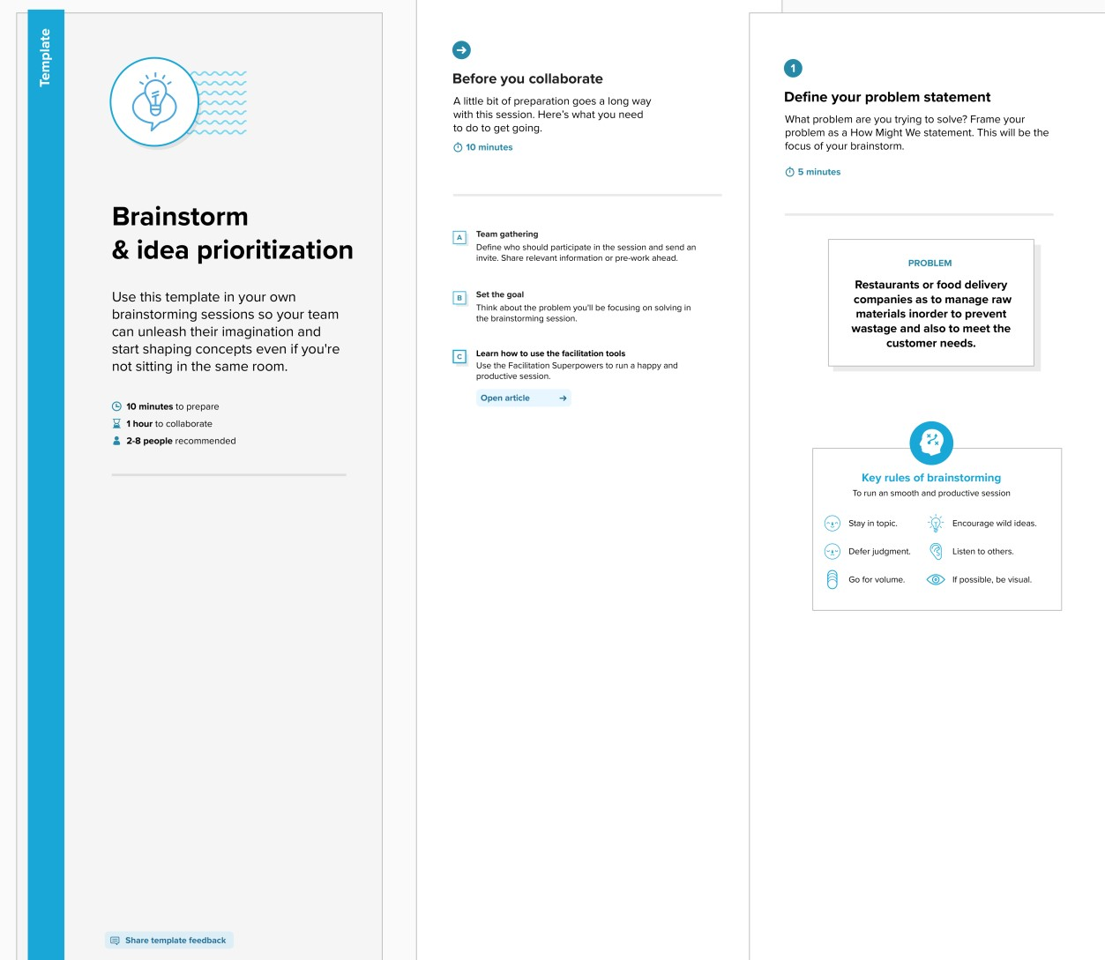

**Step-2: Brainstorm, Idea Listing and Grouping**

SYED MASTAN

SUMANTH

ABINAY KUMAR

SHASHANK

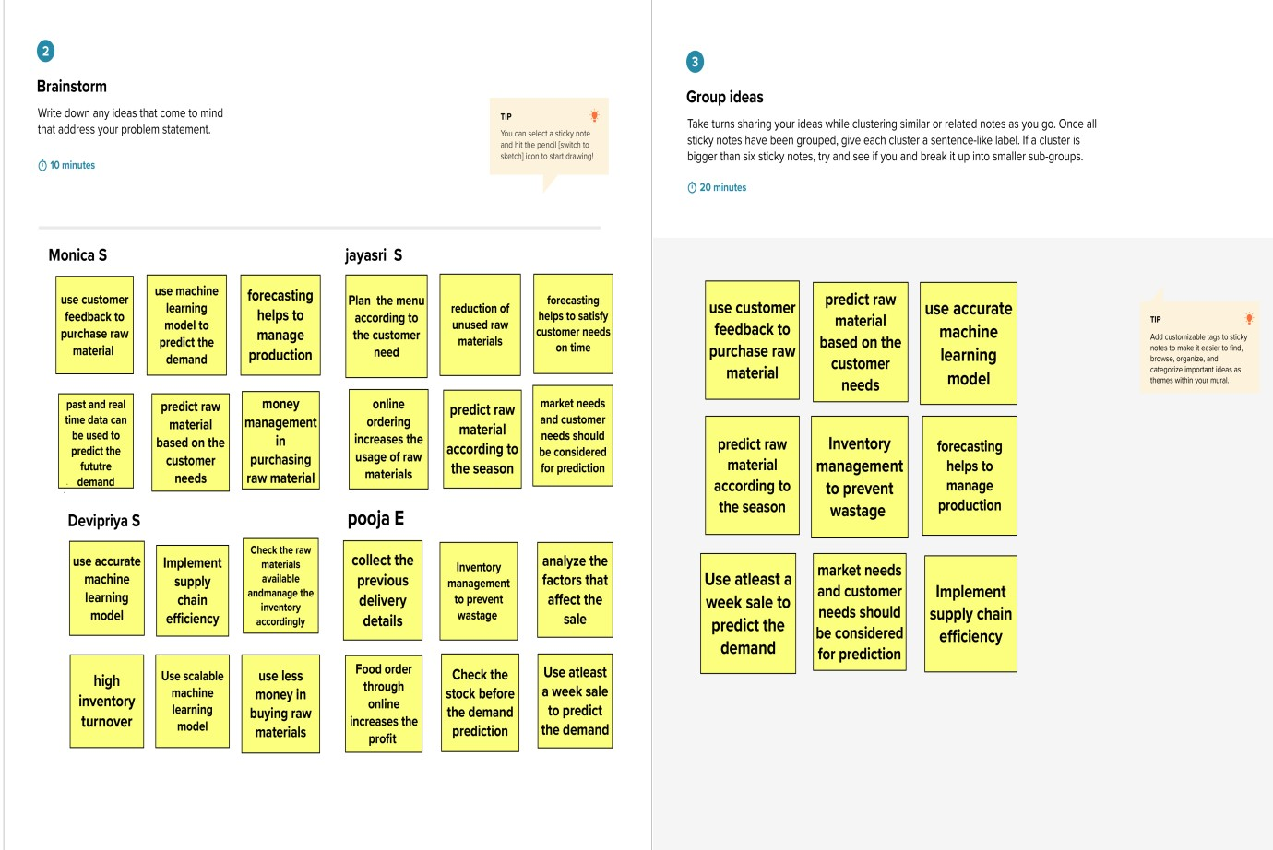

**Step-3: Idea Prioritization**

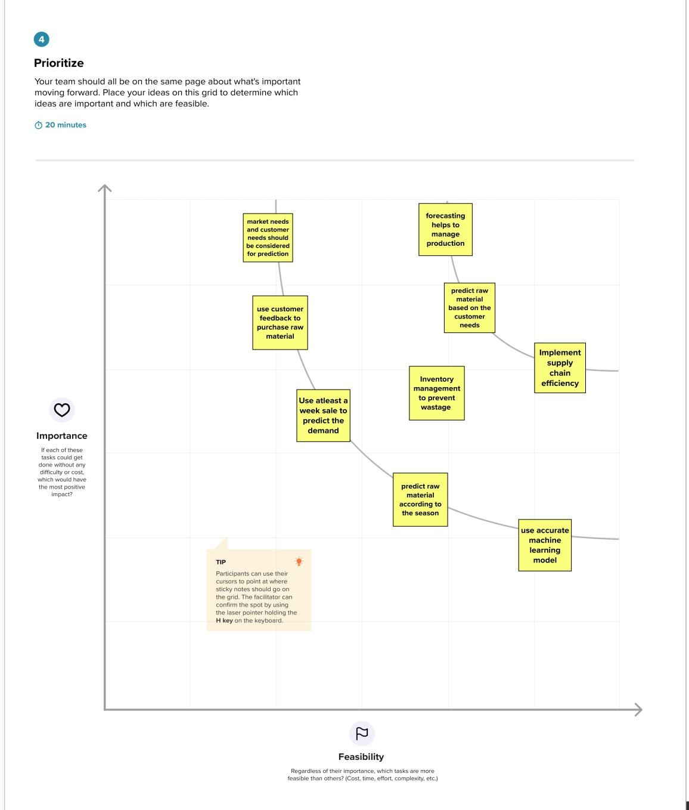

STEP 4 :

These are the steps involved in brainstorming and ideation phase